**EXPERIMENT 3**

**Title:** Designing Google Logo using GIMP

**Objective:** To design a simple logo of Google with tagline using GIMP.

**Theory:**

**GIMP** stands for GNU Image Manipulation Program. It is a cross-platform image editor available for GNU/Linux, OS X, Windows and more operating systems. It is [free software](https://www.gnu.org/philosophy/free-sw.html), and its [source code](https://git.gnome.org/browse/gimp) can be changed and [distribute](https://www.gnu.org/licenses/quick-guide-gplv3.en.html)d. Whether one is a graphic designer, photographer, illustrator, or scientist, GIMP provides with sophisticated tools to get the job done. We can further enhance our productivity with this platform. GIMP is a high-quality framework for scripted image manipulation, with multi-language support such as C, C++, Perl, Python, Scheme and more! It can be downloaded directly from www.gimp.org

**Procedure:**

**Step 1:** Open GIMP. Go to File > New. A dialog box named ‘Create a New Image’ opens. Choose 1080x1080 image size with white as background.

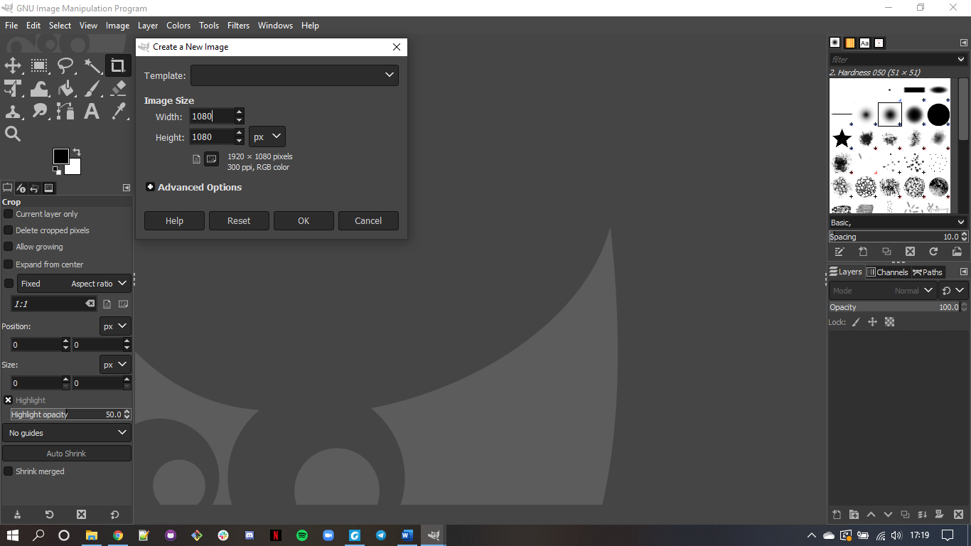

**Step 2:** Go to Image > Guides > Guides by %. Choose Horizontal guide and position it at 50%. In the similar way, set 50% vertical guide.

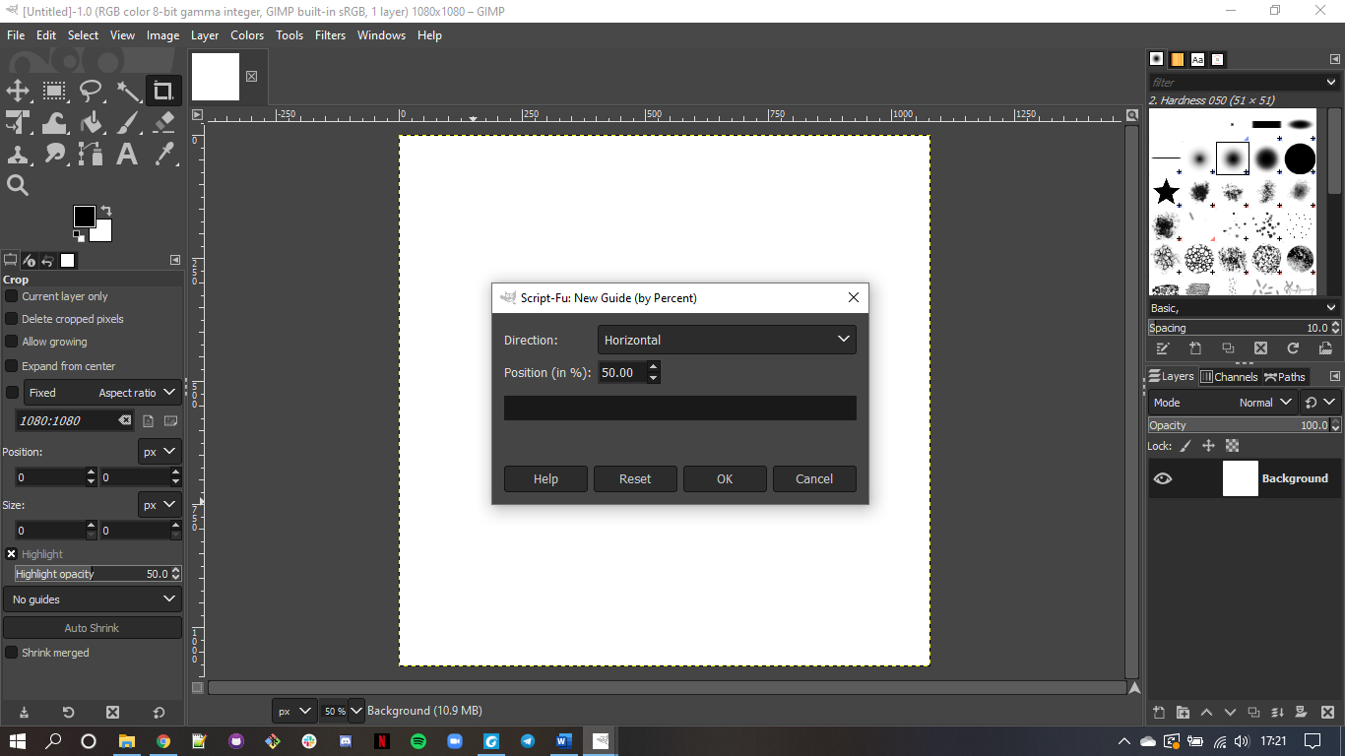

**Step 3:** Now, choose Ellipse tool from Select toolbar, and start drawing a circle in one of the quadrants of your choice. Press Ctrl+Shift to position it at the centre.

**Step 4:** Go to Select > None.

**Step 5:** Go to Path >Make the selection visible. Now, add it to the text.

**Step 6:** Right click on the text layer, choose text along path > go to path and add new layer with it.

**Step 7:** Go to path, text-1 > Transparent, fill the path >solid colour > delete text1 path.

**Step 8:** Now text-2, click to toolbar > Flip tool > Transform row > Direction Flipping.

**Step 9:** Now go to the text layer > right click on text-2 > Click on text along path > Adjust the position of 2nd text by rotate tool.

**Step 10:** Add new layer from the 2nd text, select that layer >Go to the path > Right click on it, select text along path. Fill path with solid colour.

**Step 11:** Go to file and open the google logo as layer and place it in the centre and make other layers invisible.

**Step 12:** Save the output. And export it in other location with (.xcf) extension.

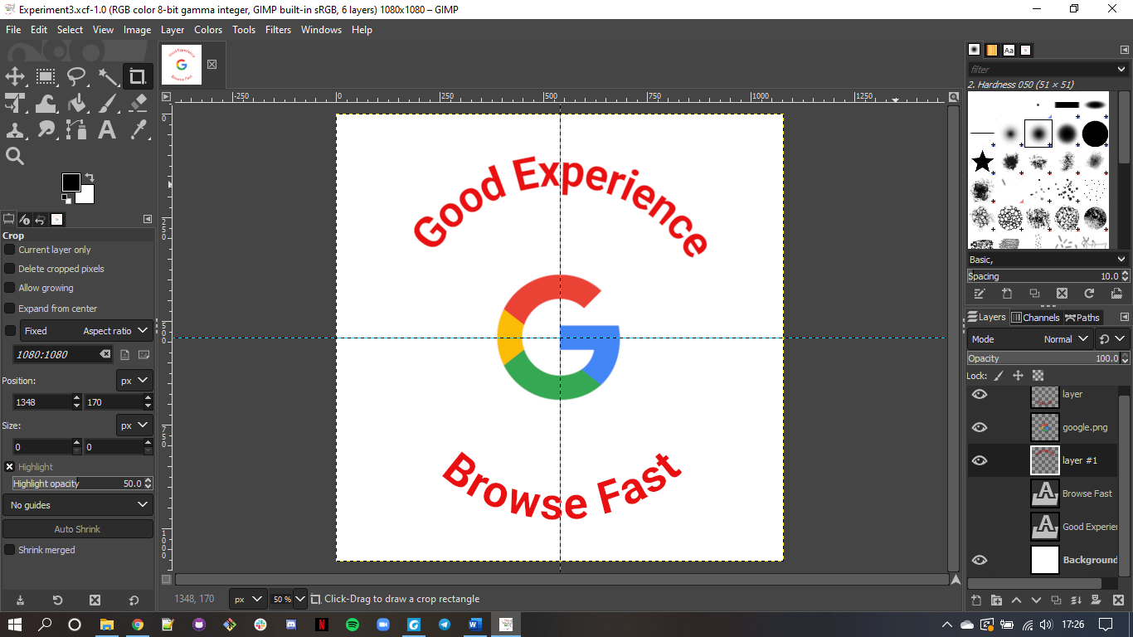

**Conclusion:** Hence, we have created a logo of Google using GIMP.